HTML & CSS DAY -21  
TASK -2

SURVEY FORM

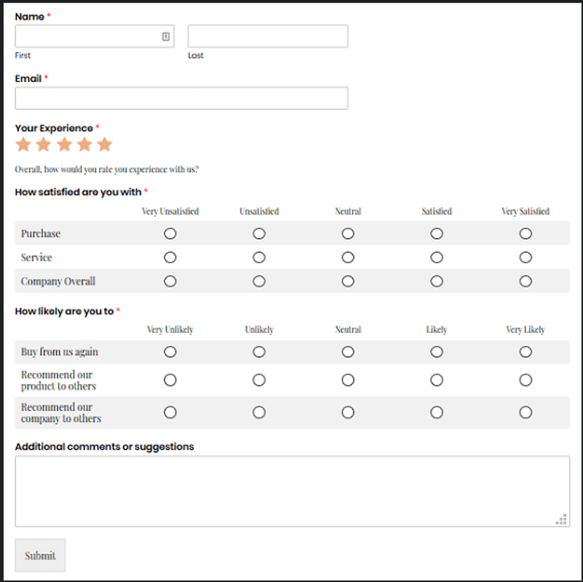

Code -  
  
<!DOCTYPE html>

<html lang="en">

<head>

<meta charset="UTF-8">

<meta name="viewport" content="width=device-width, initial-scale=1">

<title>Survey Form</title>

<link href="https://cdn.jsdelivr.net/npm/bootstrap@5.3.3/dist/css/bootstrap.min.css" rel="stylesheet">

<style>

.star-rating {

*font-size*: 1.5rem;

*color*: #f39c12;

}

.form-label.required::after {

*content*: " *";

*color*: red;

}

.table td, .table th {

*vertical-align*: middle;

*text-align*: center;

}

</style>

</head>

<body>

<div class="container my-5">

<h3 class="mb-4">Customer Feedback Form</h3>

<form>

<div class="row mb-3">

<div class="col-md-6">

<label class="form-label required">Name</label>

<div class="input-group">

<input type="text" class="form-control me-1" placeholder="First" required>

<input type="text" class="form-control" placeholder="Last" required>

</div>

</div>

</div>

<div class="mb-3">

<label for="email" class="form-label required">Email</label>

<input type="email" class="form-control" id="email" placeholder="name@example.com" required>

</div>

<div class="mb-4">

<label class="form-label required">Your Experience</label>

<div class="star-rating mb-1">

★ ★ ★ ★ ★

</div>

<small class="text-muted">Overall, how would you rate your experience with us?</small>

</div>

<div class="mb-4">

<label class="form-label required">How satisfied are you with</label>

<table class="table table-bordered align-middle">

<thead>

<tr>

<th></th>

<th>Very Unsatisfied</th>

<th>Unsatisfied</th>

<th>Neutral</th>

<th>Satisfied</th>

<th>Very Satisfied</th>

</tr>

</thead>

<tbody>

<tr>

<td>Purchase</td>

<td><input type="radio" name="purchase" required></td>

<td><input type="radio" name="purchase"></td>

<td><input type="radio" name="purchase"></td>

<td><input type="radio" name="purchase"></td>

<td><input type="radio" name="purchase"></td>

</tr>

<tr>

<td>Service</td>

<td><input type="radio" name="service" required></td>

<td><input type="radio" name="service"></td>

<td><input type="radio" name="service"></td>

<td><input type="radio" name="service"></td>

<td><input type="radio" name="service"></td>

</tr>

<tr>

<td>Company Overall</td>

<td><input type="radio" name="company" required></td>

<td><input type="radio" name="company"></td>

<td><input type="radio" name="company"></td>

<td><input type="radio" name="company"></td>

<td><input type="radio" name="company"></td>

</tr>

</tbody>

</table>

</div>

<div class="mb-4">

<label class="form-label required">How likely are you to</label>

<table class="table table-bordered align-middle">

<thead>

<tr>

<th></th>

<th>Very Unlikely</th>

<th>Unlikely</th>

<th>Neutral</th>

<th>Likely</th>

<th>Very Likely</th>

</tr>

</thead>

<tbody>

<tr>

<td>Buy from us again</td>

<td><input type="radio" name="buy_again" required></td>

<td><input type="radio" name="buy_again"></td>

<td><input type="radio" name="buy_again"></td>

<td><input type="radio" name="buy_again"></td>

<td><input type="radio" name="buy_again"></td>

</tr>

<tr>

<td>Recommend our product to others</td>

<td><input type="radio" name="recommend_product" required></td>

<td><input type="radio" name="recommend_product"></td>

<td><input type="radio" name="recommend_product"></td>

<td><input type="radio" name="recommend_product"></td>

<td><input type="radio" name="recommend_product"></td>

</tr>

<tr>

<td>Recommend our company to others</td>

<td><input type="radio" name="recommend_company" required></td>

<td><input type="radio" name="recommend_company"></td>

<td><input type="radio" name="recommend_company"></td>

<td><input type="radio" name="recommend_company"></td>

<td><input type="radio" name="recommend_company"></td>

</tr>

</tbody>

</table>

</div>

<div class="mb-3">

<label class="form-label">Additional comments or suggestions</label>

<textarea class="form-control" rows="4" placeholder="Your feedback..."></textarea>

</div>

<div>

<button type="submit" class="btn btn-secondary">Submit</button>

</div>

</form>

</div>

<script src="https://cdn.jsdelivr.net/npm/bootstrap@5.3.3/dist/js/bootstrap.bundle.min.js"></script>

</body>

</html>